
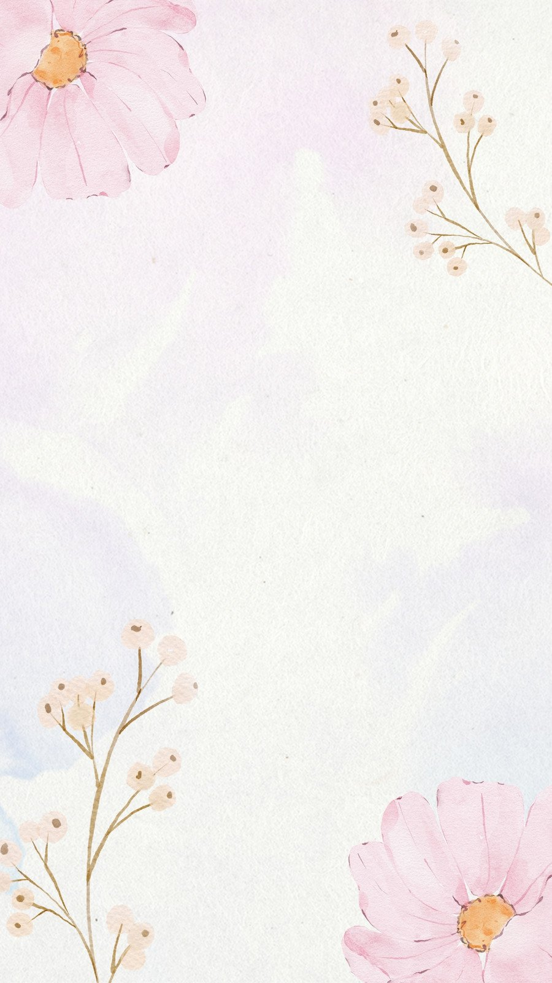

VENUE: sawantwadi
At 123 naikwada , Gandhi nagar
Shree Building 18floor

Saturday March27 2pm

sham
P A R T Y

